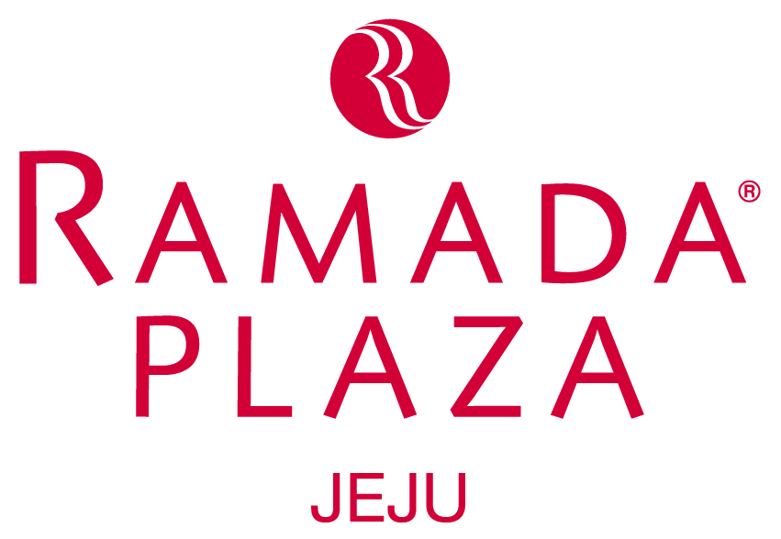
Hotel Reservation Form

NAME OF EVENT: ITS-IFToMM / K-TIS 2017

Contact us  Fax/e-mail to | RAMADA PLAZA JEJU HOTEL (in S. Korea)
Contact us  Fax/e-mail to | MS. Kim Su-Young  Tel: +82-2-3672-8700 e-mail: ramadajeju1004@naver.com Fax : +82-2-3672-8700

Please, make out the following room reservation (Field marked with asterisks (*) are essential.)
*MS.( ) | MR.( ) | *Last Name : |  | *First Name :
*MS.( ) | MR.( ) | *Last Name : |  | *First Name :
Organization Company
Address
Country |  |  | City
*Telephone |  |  | Fax.
*e-mail
*Arrival Date |  |  | *Departure Date
*Room Type |  | Twin Room  -Two bed * ( ) | Mountain view |  |  | KRW 170,000/ per day *( )
 |  | Twin Room  -Two bed * ( ) | Habour view |  |  | KRW 170,000/ per day *( )
 |  | Twin Room  -Two bed * ( ) | Ocean view |  |  | KRW 170,000/ per day *( )
Remarks |  | Weekend (Fri, Sat) will be Extra Charge KRW 60,000 each price per day.
1. All of the above rates are quoted on a room, per night basis, subject to 10% government tax.
2. Breakfast is included. (Breakfast: KRW 24,000/person)
3. Dead line for reservation is Cut-off date.
4. Please, send your reservation form by e-mail to MS. Kim Su-Young until deadline.

Booking Guaranteed:
Credit Card Type : |  | Name on Card :
Credit Card No. :
Signature : |  | Exp. Date : | ( / ) MM/YYYY

Cancellation Policy:
If you cancel your reservation, you will incur a cancellation charge as follows.
Period | 5 day ago | 4 to 2 day | 1 day ago | before 6 pm  the arrival date | after 6 pm and no show the arrival date
Penalty | N/A | 20% | 30% | 50% | 80%

